This is a simple readme to show how to OTA a NodeMCU.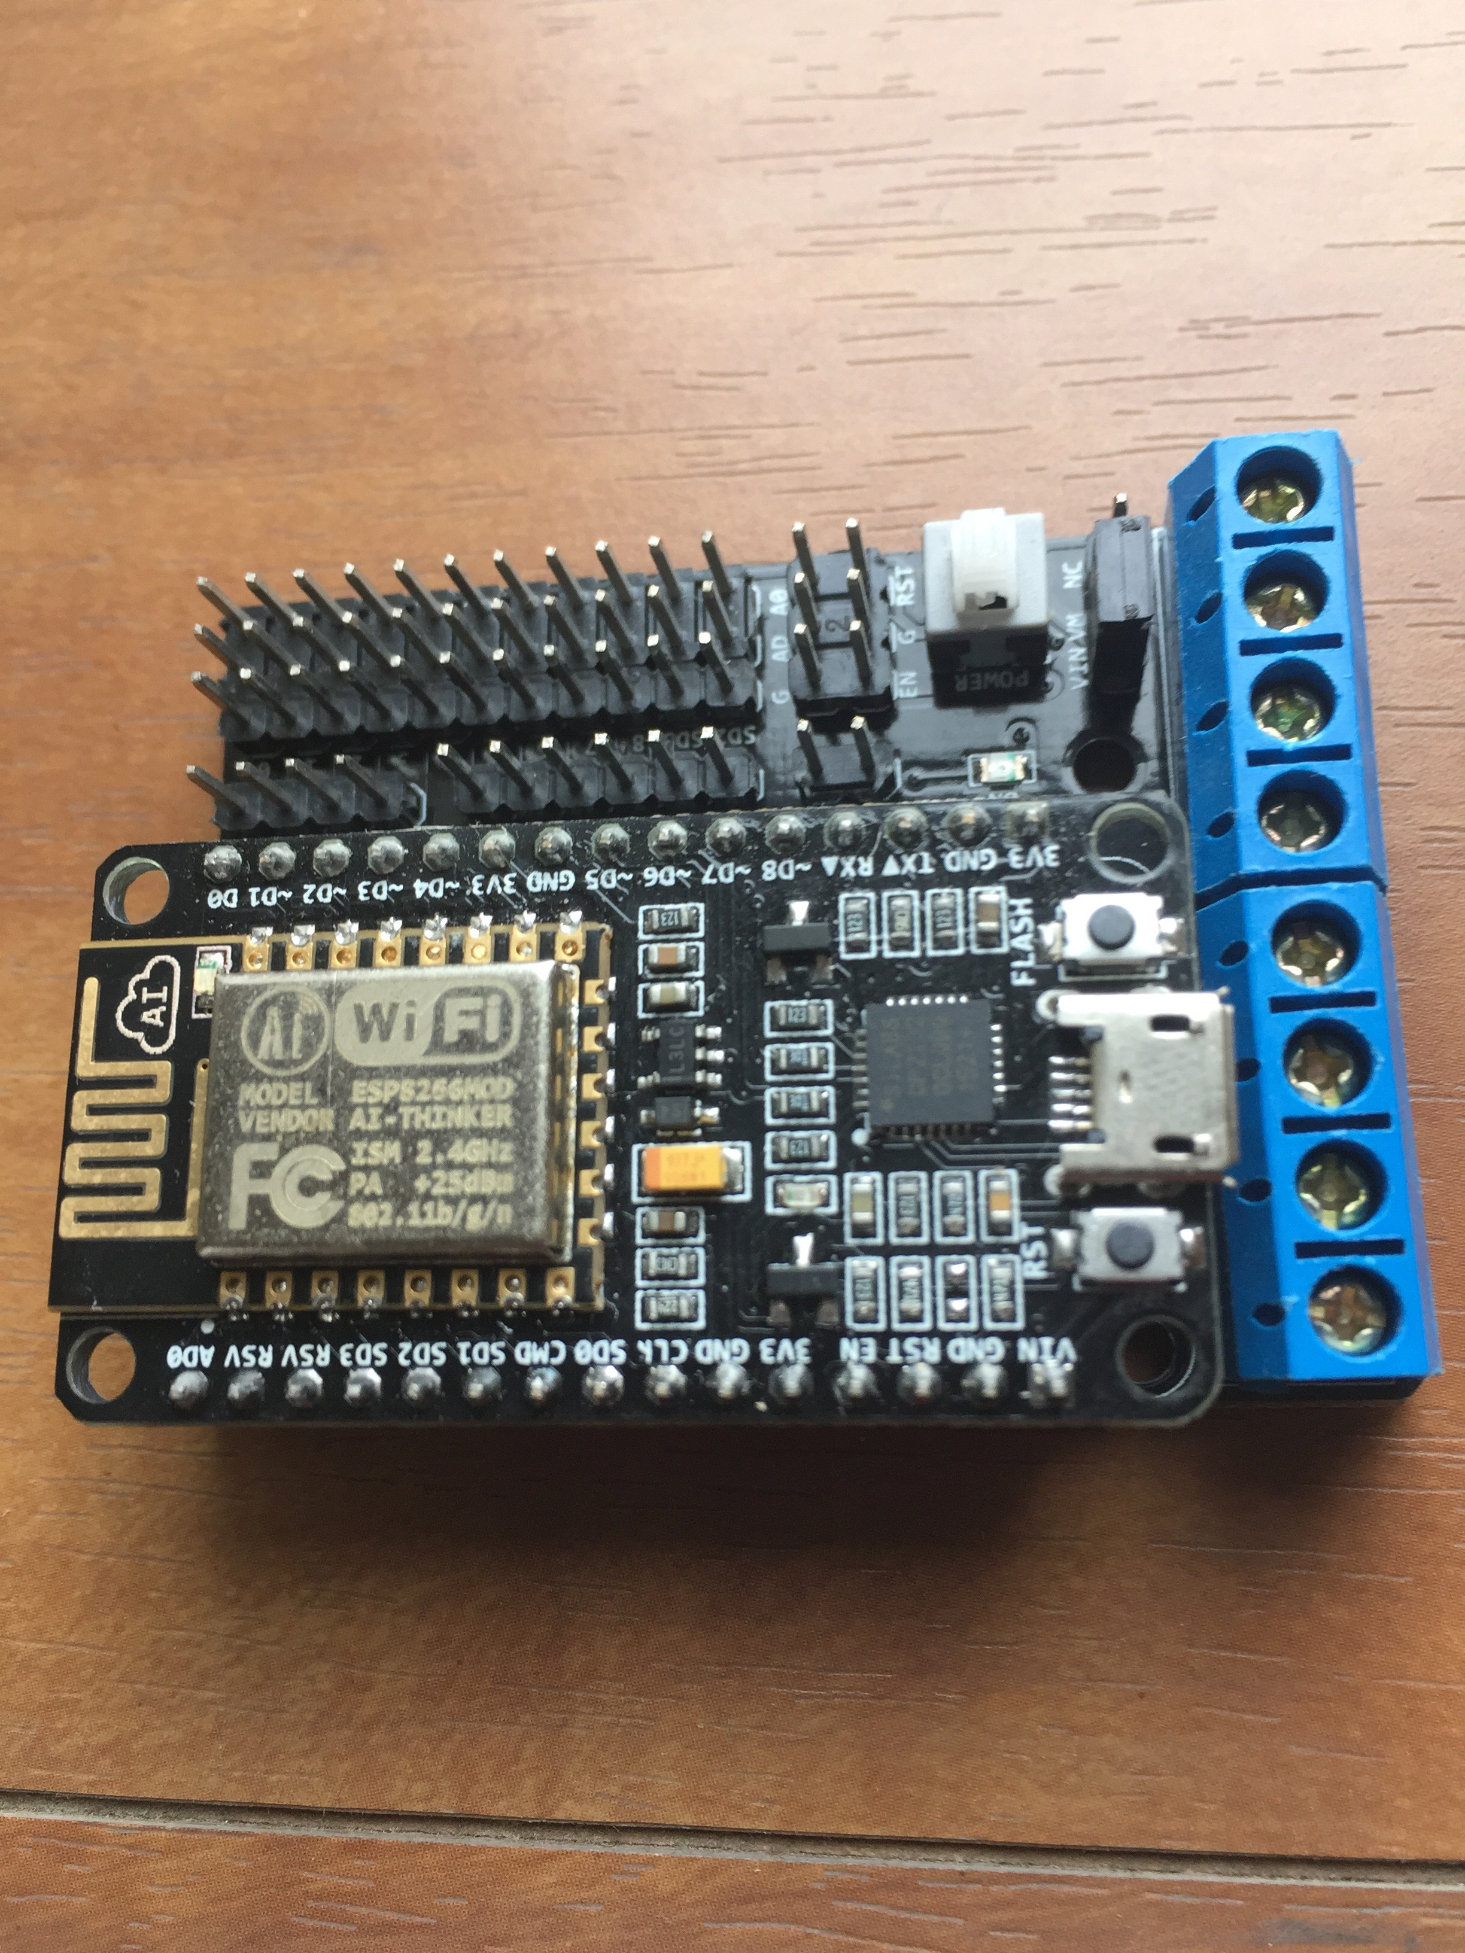

1. Download & install the latest Arduino IDE, i.e. my version is 1.8.5

<https://www.arduino.cc/en/Main/Software>

2) Open the IDE & go to the Presence menu. Add the link to the Additional Board Manager URLs. TO choose the ESP8266 library & download the packages.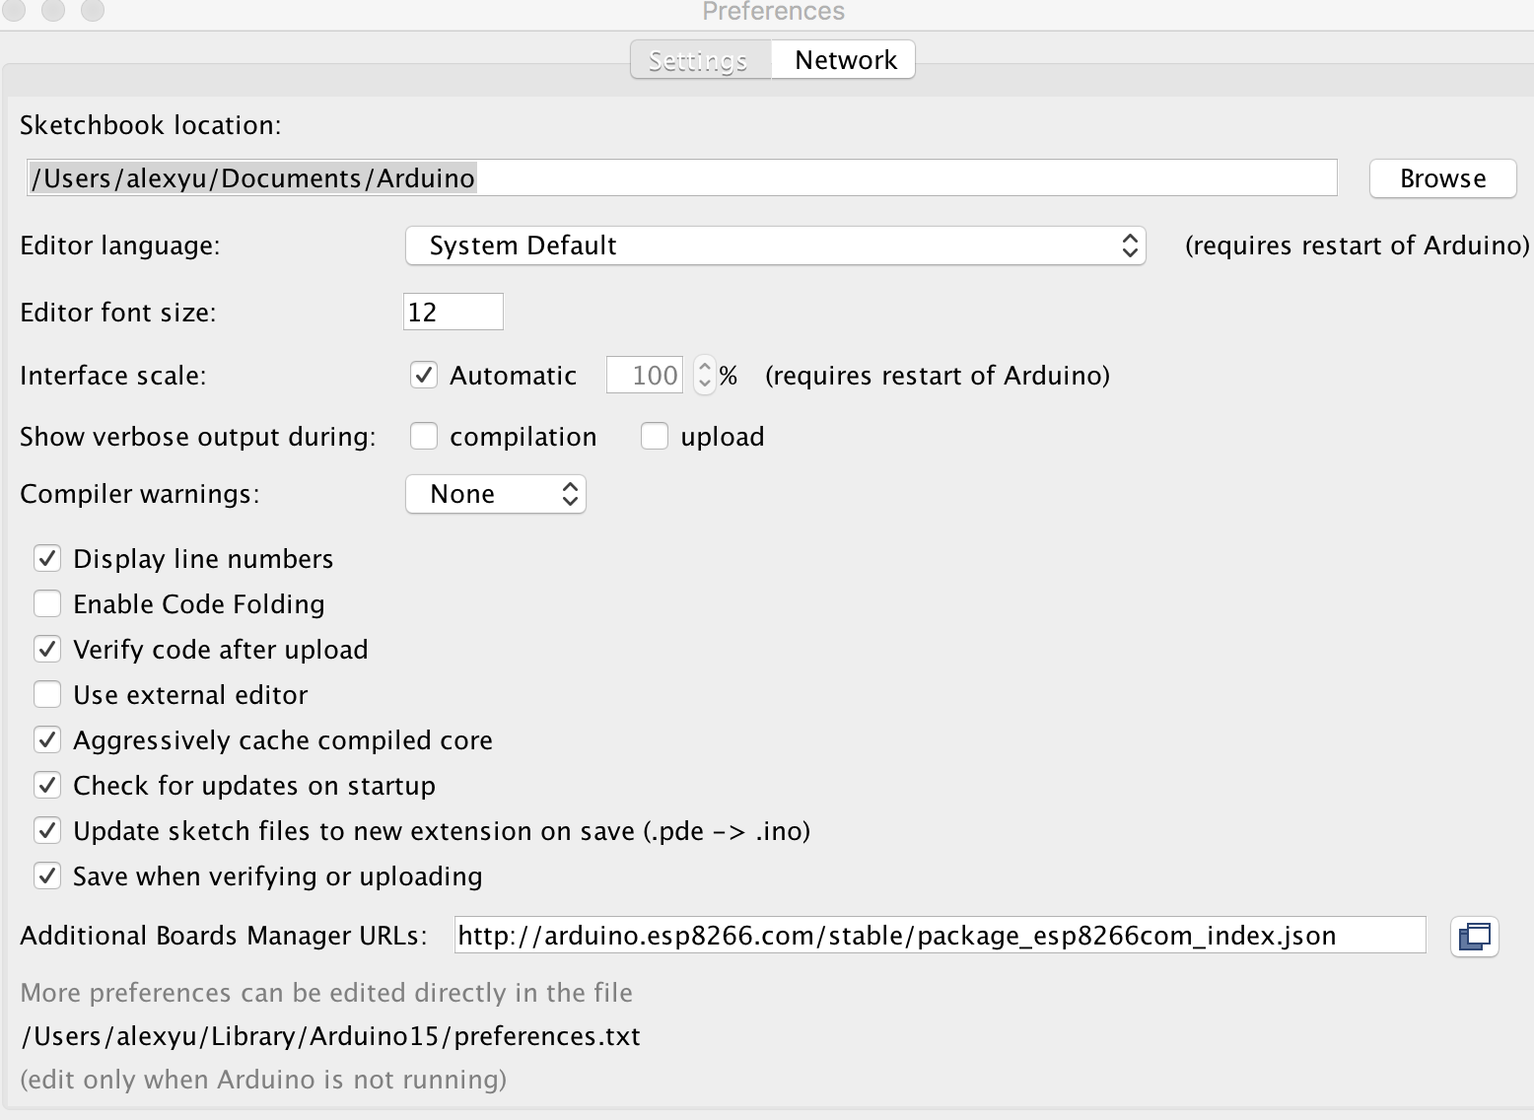

3) Once the download is completed, you may see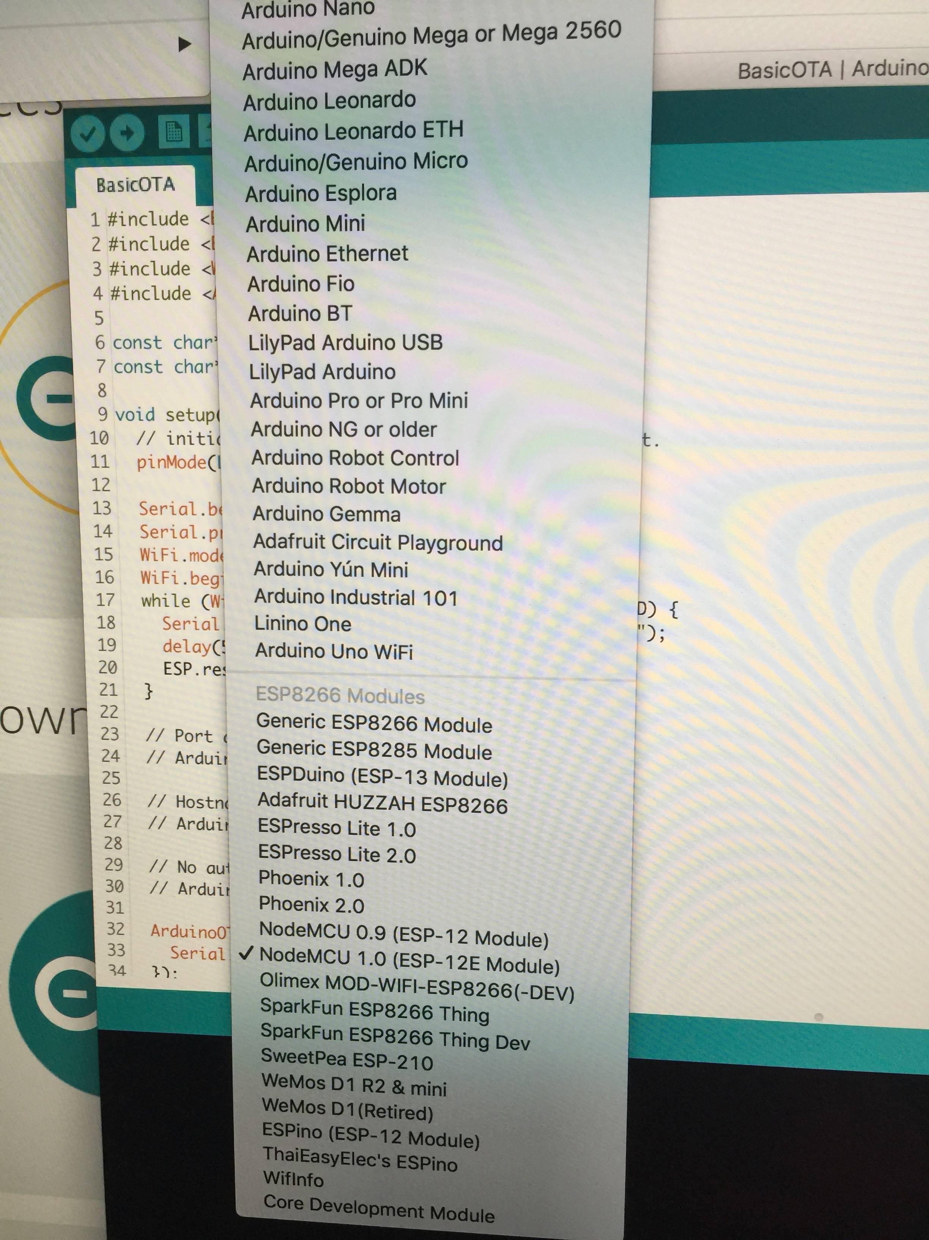 the new NodeMCU 1.0 board.

Connect the NodeMCU board to your host ( I am using Mac), you will see the new PORT connected “.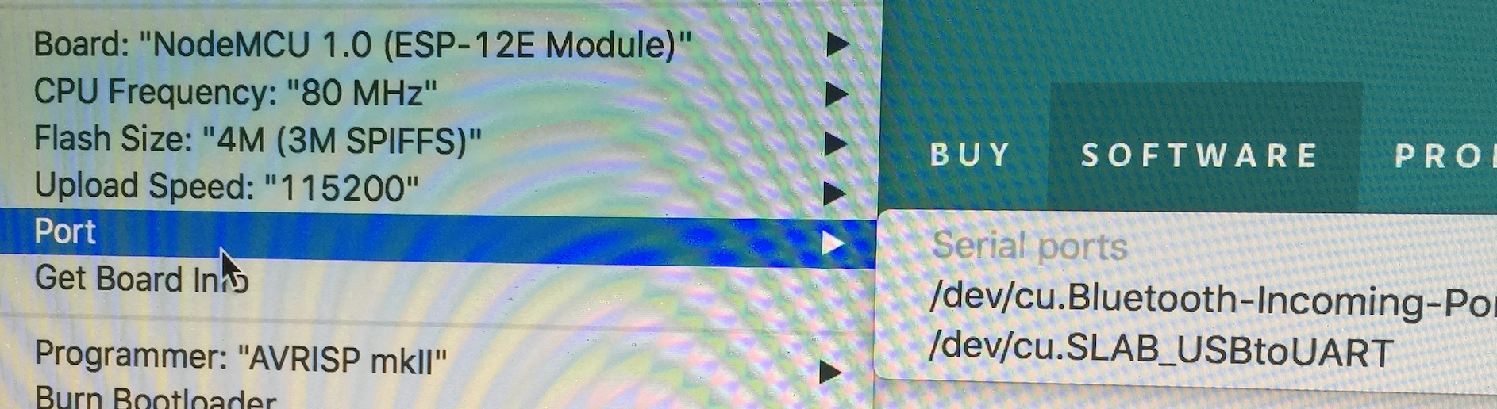

4) Go to the File Menu and choose the Example for the NodeMCU, there is a BasicOTA example.

5) Change the SSID & its password to the wifi router your host is using now.

const char* ssid = “example SSID";

const char* password = “password";

6) You may add a LED flashing in the loop to prove that the new OTA firmware is uploaded.

void loop() {

ArduinoOTA.handle();

digitalWrite(LED_BUILTIN, HIGH); // turn the LED on (HIGH is the voltage level)

delay(1000); // wait for a second

digitalWrite(LED_BUILTIN, LOW); // turn the LED off by making the voltage LOW

delay(1000); // wait for a second

}

7) Press upload button to upload the OTA program.

8) Once it is completed, you should see the new LED flashing patten & you are free to unplug the board from the host now.

10) You could power up the nodeMCU board with a standalone battery.

11) A few seconds later, you should able to see the nodeMCU is connected to your wifi router & you should able to see a new port connection.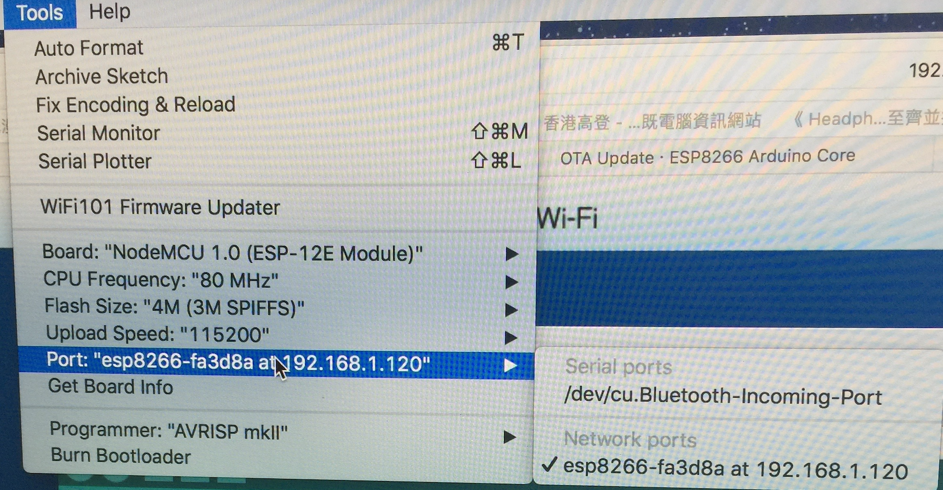

12) Then you should free to upload the firmware by OTA now.

Reference:

http://esp8266.github.io/Arduino/versions/2.0.0/doc/ota_updates/ota_updates.html#arduino-ide

<https://randomnerdtutorials.com/esp8266-ota-updates-with-arduino-ide-over-the-air/>